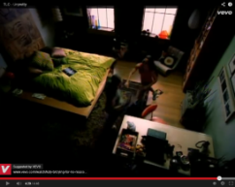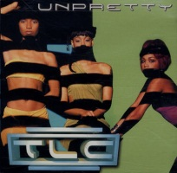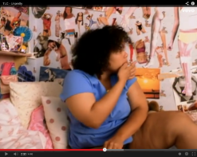

Insecurity

Girls inner beauty

Producer: Dallas Austin

Girlfriend is encouraged by her boyfriend to get breast implants

Facial expressions:

* Fake smile
* Confusion
* Shame
* Anger
* Sadness
* Happiness

$1.6 million

Pop & RnB

Realisation

Promotion

Teenager worried about “fitting in” to the ideal world

TLC – Unpretty

July 1999

July 9thy, 1999

This song talks about girls' inner beauty. The first line "I wish I could tie you up in my shoes make you feel unpretty too," is talking about the people who say that a person is ugly. Chili sings about satisfying her boyfriend for what he wants from her. In the video, she and her boyfriend are looking at an online web page of a hospital which specializes in breast implants. Her boyfriend would like Chili to get bigger breasts, but she thinks that she shouldn't. The video continues with more scenes of people compromising their health and principles for the sake of beauty, including a girl who uses bulimia to stay thin.

I have chosen to promote this video now in 2014 to raise awareness of the goings on that continue to occur from society as a form of alienation toward not just young females but young people in general.