**1960’s**

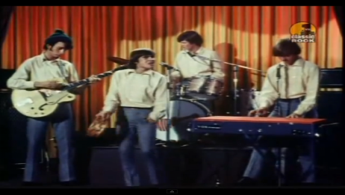The Monkees – I’m a believer

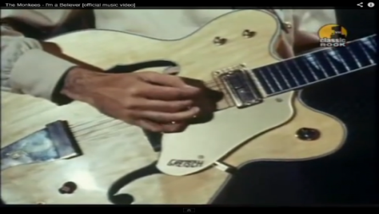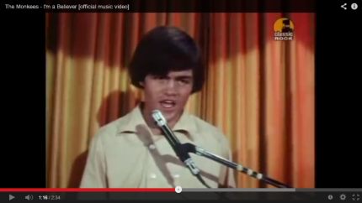

In the 1960’s music videos were basic meaning they were simply videos of the band/singer on a stage performing. Occasionally they’d have an extreme close up shot of the instrument being played.

Target audience: teenage girls because it’s a love song.

Institution: Cost of Production: Producers: Jeff barry Label: Colgems Records

**1970’s**

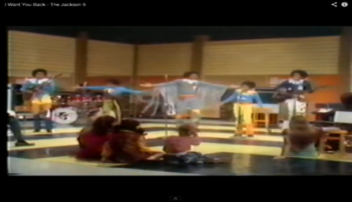Jackson 5 – I want you back

Colour of the costumes have become brighter. The target audience for this music video would be for young girls, notice the 3 young girls sitting at the front. A lot more dancing and co-ordination compared to the 10960’s.

Recorded July 1969 The Sound Factory, West Hollywood

Genre Soul, funk, pop

Length 2:59

Label Motown

The Corporation - Berry Gordy, Freddie Perren, Alphonzo Mizell and Deke Richards

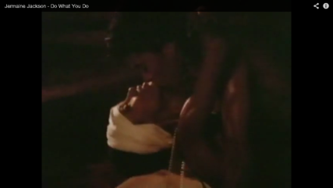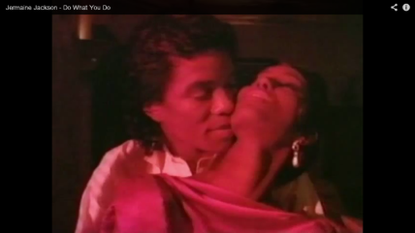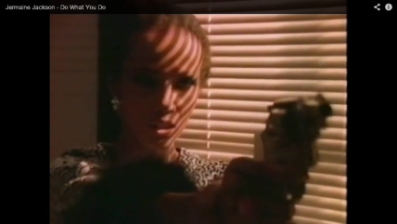**1980’s**

In the 1980’s music videos began to develop more of a story line to them. Jermaine Jacksons Do what you do I believe had a target audience of about 20-30 year olds because there are some mild sexual and violent scenes

Released: December 21, 1984 Genre: R&B

Length 4:46 Label Arista Writer(s) Larry Ditommaso, Ralph Dino Producer Clive Davis, Jermaine Jackson

**1990’s**

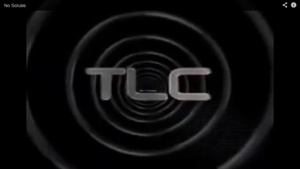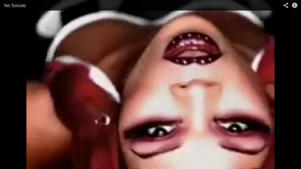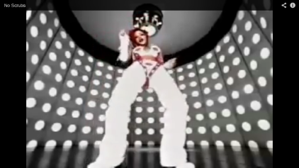

A lot of colour, dancing and technology goes into the music videos of the 90’s. Compared to the 1960’s with a basic video of the band/ singer on stage, this music video for TLC “Scrubs” has a completely new style. The target audience for this music video I would say was 16-30 because the fashion sense would appeal to young women and the lyrics would appeal to slightly older women.

Released January 23, 1999 Recorded December 1998; Genre R&B, hip hop, dance Length 4:00 (video version) Label LaFace, Arista Writer(s) Kevin "She'kspere" Briggs, Kandi Burruss, Tameka "Tiny" Cottle, Lisa "Left Eye" Lopes Producer Kevin "She'kspere" Briggs Certification